Urban Ecosystem-based Adaptation for Climate Resilient Development in the Kathmandu Valley, Nepal

Event Completion Report

An Open Day Program to Demonstrate Outcomes of Urban EbA Interventions to Participants

Venue: Jana Uddhar Secondary School, Gamcha
Budhanilkantha Municipality
Date: 1 September 2025



Prepared By:
Project Management Unit
Urban EbA

Introduction
The Kathmandu Valley, situated in the mid-hill region of Nepal, is highly vulnerable to the impacts of climate change. Although the valley receives, on average, between 1600 and 2000 mm of rain annually, rainfall distribution has become increasingly erratic over the last three decades. Prolonged dry spells followed by short, intense rainfall events have led to recurrent urban flooding, soil erosion, and a deficit of groundwater recharge. Seasonal water shortages are now a critical challenge for households, institutions, and especially schools, where drinking water and sanitation needs are directly linked to students' health and learning conditions. Rising temperatures have further worsened the problems by raising water demand while degrading freshwater ecosystems and water availability. All of these challenges draw attention to the urgent need for adaptation measures, including technology transfer and installations to enable groundwater ecosystems and improve sustainable water access in schools while safeguarding kids' resilience, education, and health.

Access to water is necessary for drinking and bathing, as well as agriculture and industry. It is also critical to the health and survival of natural ecosystems and the services they provide. A considerable amount of the water needed for these purposes comes from rainfall. Rainwater harvesting is an important water management activity that involves collecting and storing rainwater using a variety of methods and systems. This form of harvesting rainwater conserves water resources, reduces reliance on traditional water sources, and manages storm water runoff, which can help minimize flooding and soil erosion. Rainwater harvesting serves the main purpose of increasing water availability by gathering and storing rainwater for sustainable use and decreasing the demand for limited groundwater and other water sources.

To contribute to addressing the problems created by water scarcity, groundwater depletion, and local flooding at community schools, including Jana Uddhar Secondary School, Gamcha, Budhanilkantha, a rainwater harvesting project was installed and implemented. Rainwater was collected from the roof catchment using a PVC pipe of diameter 110 mm and a 500-liter rapid sand filter, where water purification is also handled. Later, the water was stored in a reserve tank, which served a variety of purposes in maintaining the personal hygiene of students and teachers, and surplus water was directed to the recharge well for groundwater recharge. Along with this, plantation activities were conducted on school grounds, to encourage environmental preservation. In order to increase greenery and improve the general school atmosphere, a sizable number of trees and other plants were planted in the accessible open places. Students, instructors, and school staffs all actively participated in the activity, which helped young learners develop a feeling of duty toward nature and an understanding of the environment.

This report details the informational sessions and activities that students and instructors held on rainwater harvesting, groundwater recharge and plantation activities. This has led to serving various purposes within the school's premises, easing the lives of school students and teachers.

Objectives
The main objectives of the open day session are listed below:
- To inform on the implementation of urban EbA activities including rainwater harvesting and plantation on school grounds and demonstrate the numerous benefits of those interventions.
- To raise awareness about the importance of water and its resources among community members, students, teachers, and parents.
- To foster a culture of water conservation among students, teachers, parents, and the local community.
- To encourage students to hold information sessions about the rainwater harvesting system that has been installed at their school.

Discussions
The school held an open day for teachers, students, parents, and the organizing committee. The committee provided an overview of the piloted project and its importance in the daily lives of students and teachers. A speech was delivered by the principal and teachers regarding the project's advantages for the school and its students. “The school's main issue was a lack of water; students were having a hard time, which worsened the health issue,” said one of the teachers.

The implementation of rainwater collection and the development of vegetation surrounding the school area were the topics of a discussion led by ecological club students. Community members and the parents visited and watched the site where rainwater harvesting has been established in order to have a thorough knowledge of the rainwater collection process and the benefits that the project offers. Students gave a demonstration of the various uses for the water that was collected within the school.

Learnings
Listed below are the major takeaways from the open day session:
- Deepen understanding of the importance of conservation of water and its resources and sustainability.
- Understand and gain ideas on rainwater harvesting, groundwater recharge and greenery promotion.
- Have a deep understanding of ways to improve water quality and maintain greenery around the school area.
- Gain knowledge and ideas on fostering water conservation.

Outcomes
The participants, including teachers, students, and parents, were able to:

- Understand the concept of the importance of water and its resources.
- Gain a deep understanding of the concept of rainwater harvesting intervention, groundwater recharge, and the role of RWH in reducing local floods.
- Gain knowledge on numerous ways to use harvested water in household activities.

Attendance
Attendance of Open Day Program (Students)
Venue: Jana Uddhar Secondary School, Budhanilkantha Municipality
Date: 1 September 2025 (16 Bhadra 2082)
S.N | Full Name | Gender (Male, Female, Other, Prefer not to say) | Age
1 | Rabina Tamang | Female | 16
2 | Niruta Thapa | Female | 16
3 | Rubi Bohora | Female | 14
4 | Swostika Shrestha | Female | 15
5 | Anisha Magar | Female | 14
6 | Gurash Tamang | Female | 15
7 | Lokesh Shah | Male | 14
8 | Samir Sunar | Male | 13
9 | Kunga Sherpa | Male | 15
10 | Raja Alam | Male | 13
11 | Ayush Tamang | Male | 12
12 | Manish Shrestha | Male | 18
13 | Yubraj Magar | Male | 17
14 | Harish Jora | Male | 16
15 | Tina Limbhu | Female | 13
16 | Chetmaya B.K | Female | 15
17 | Rekha Chamling | Female | 15
18 | Bhawana Rokaya | Female | 14
19 | Manisha Tamang | Female | 13
20 | Muskan Shah | Female | 12
21 | Nersang Tamang | Female | 14
22 | Asmita Pariyar | Female | 14
23 | Ayushma Pande | Female | 13

Attendance of Open Day Program (Teachers and School Staffs)
Venue: Jana Uddhar Secondary School, Budhanilkantha Municipality
Date: 1 September 2025 (16 Bhadra 2082)
S.N | Full Name | Gender (Male, Female, Other (prefer not to say) | Contact
1 | Hare Ram Khatri | Male | 9841383839
2 | Topnath Ghimire | Male | 9841419315
3 | Asha Khadka | Female
4 | Apsara Ghimire | Female | 9848582724
5 | Rajina K.C. | Female | 9860625605
6 | Sunita Sharma | Female
7 | Shiva Bahadur Thapa | Male | 9843606535
8 | Shanti Nagarkoti | Female | 9849442469
9 | Roshan Sharma | Male | 9841622402
10 | Rojina Thapa | Female
11 | Samjhana Shrestha | Female | 9823221489
12 | Basu Dev Tiwari | Male | 9841690760
13 | Subash G.C. | Male | 9848297087
14 | Sharmila Rai | Female | 9869731169
15 | Buddhi Chand Shrestha | Male | 9841547654

Attendance of Open Day Program (Parents/Local)
Venue: Jana Uddhar Secondary School, Budhanilkantha Municipality
Date: 1 September 2025 (16 Bhadra 2082)
S.N | Full Name | Gender (Male, Female, Other, Prefer not to say) | Contact
1 | Rubi Shrestha | Female | 9816319881
2 | Sanjana Tamang | Female | 9841861409
3 | Tara Bohora | Female | 9846248387
4 | Nathuni Shah | Male | 9818904189
5 | Jaya Bahadur Tamang | Male | 9841163616
6 | Pushpa Kiran Magar | Male | 9865982399
7 | Rabi Nepali | Male | 9862787400
8 | Sukha Raj Rai | Male | 9761415518
9 | Mando Saren | Female
10 | Deepa Pariyar | Female
11 | Nanakali Magar | Female | 9860306726
12 | Kishnamaya Khatri | Female
13 | Smriti Tamang | Female | 9803193548
14 | Urmila Nagarkoti | Female | 9847688012
15 | Shanta Sunuwar | Female
16 | Putali Thapa | Female
17 | Kamala Adhikari | Female
18 | Karishma Rokaya | Female
19 | Dhansara Rokaya | Female
20 | Lakpa Sherpa | Male
21 | Sharmila Shrestha | Female
22 | Rekhha Shrestha | Female

Attendance of Open Day Program (Organiser)
Venue: Jana Uddhar Secondary School, Budhanilkantha Municipality
Date: 1 September 2025 (16 Bhadra 2082)
S.N | Full Name | Gender (Male, Female, Other, Prefer not to say) | Contact
1 | Durga Prasad Upadhyay | Male | 9841510361
2 | Uday Kumar Pokharel | Male | 9803622493
3 | Dharma Raj Gaudel | Male | 98400610079
4 | Bishna Subedi | Female | 9849202652
5 | Prashamsa Sharma | Female | 9860033537
6 | Pramod Upreti | Male | 9841825742

Photos of the Events
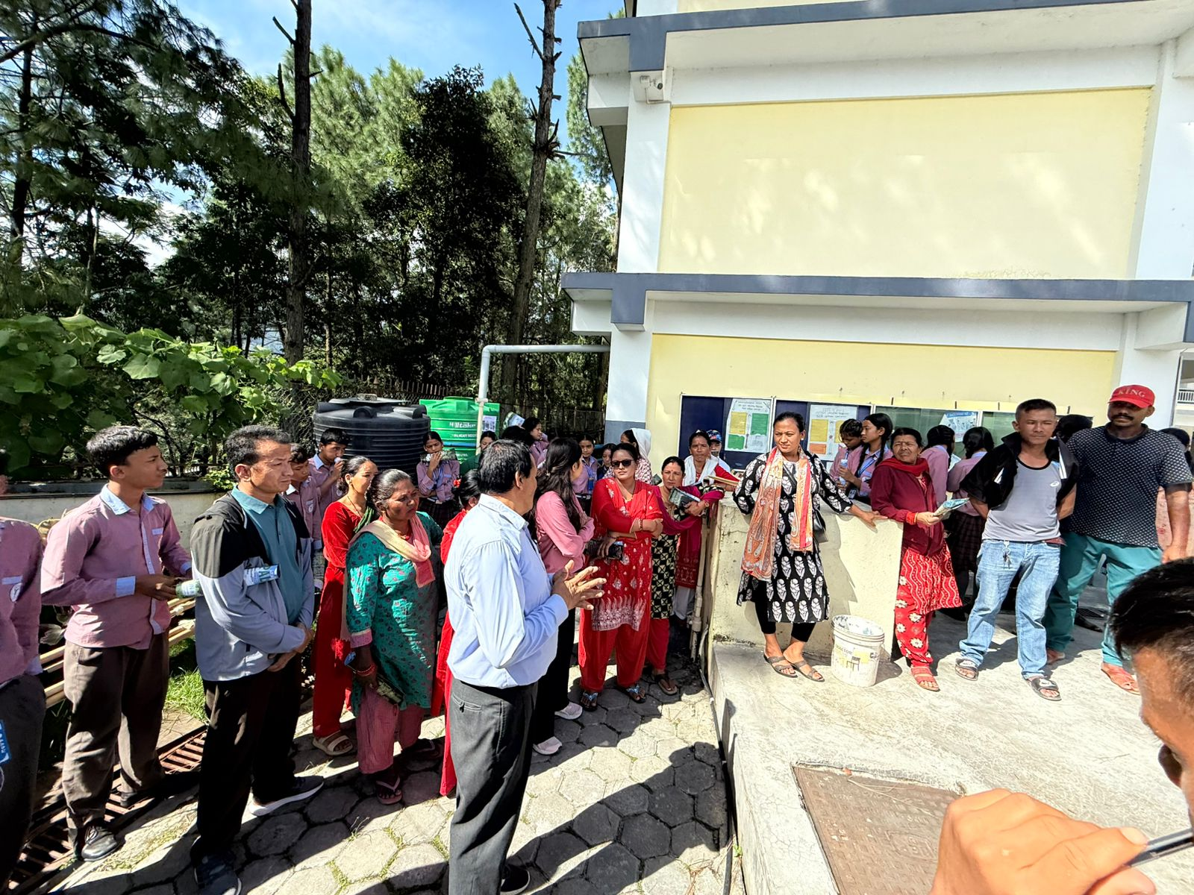

Students, parents, and teachers visiting school premises to observe the location where rainwater harvesting is implemented

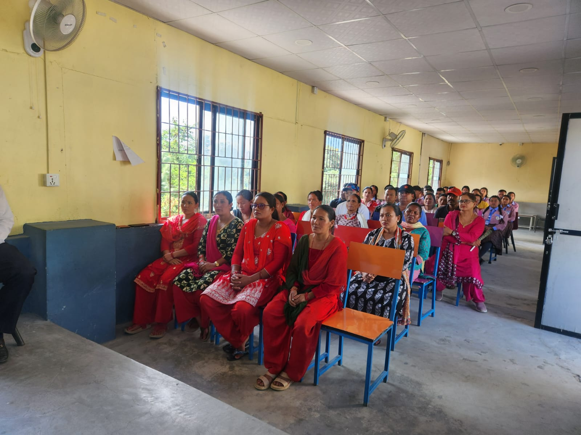
Participants attending the open day session on Rainwater
Harvesting conducted by Jana Uddhar Secondary School
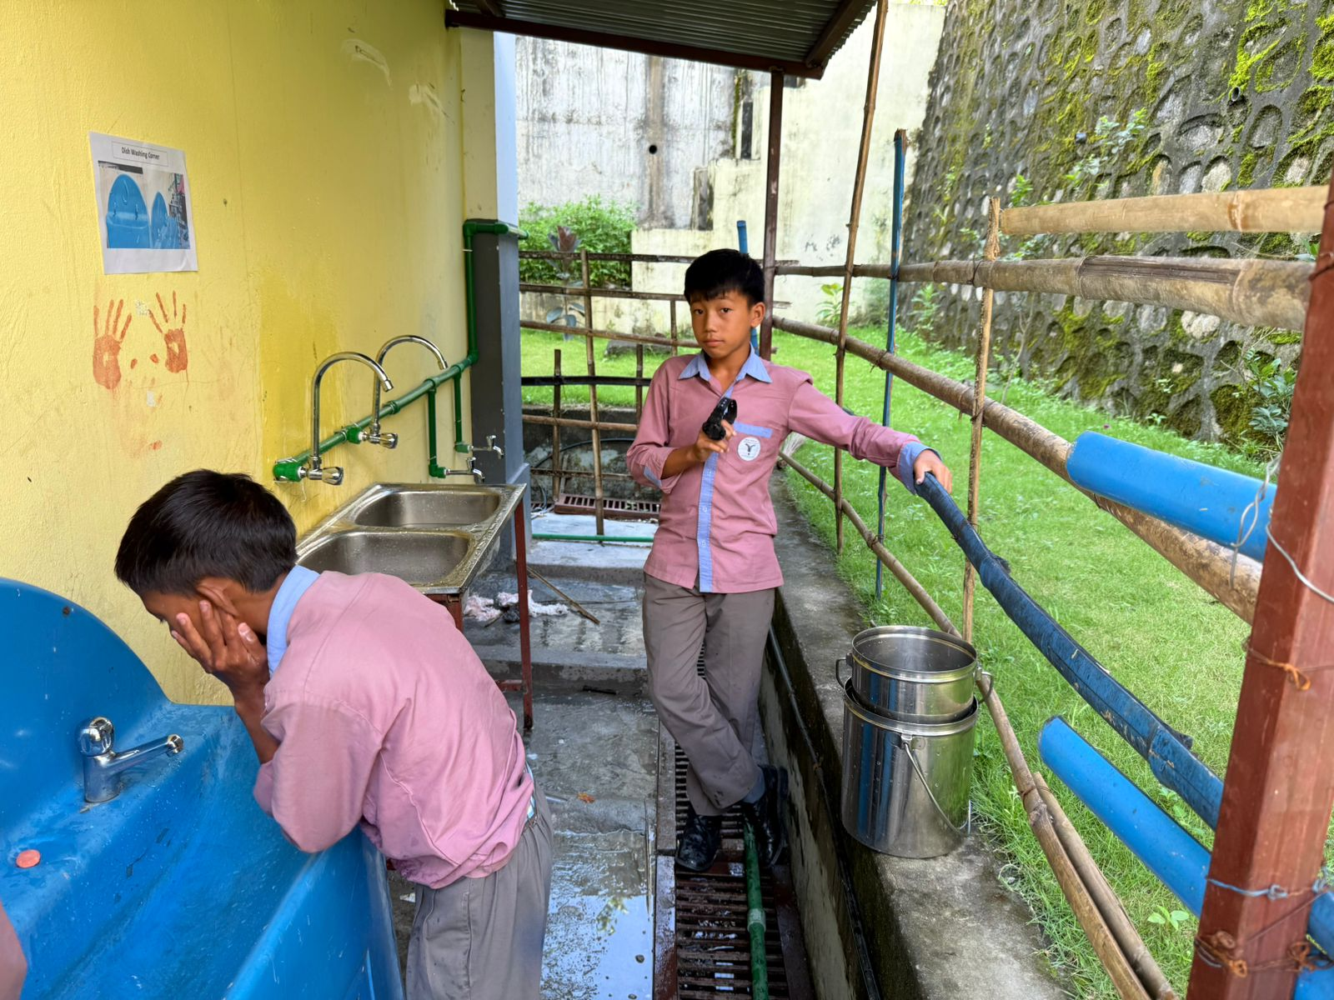

Students utilizing harvested rainwater for sanitation purposes.

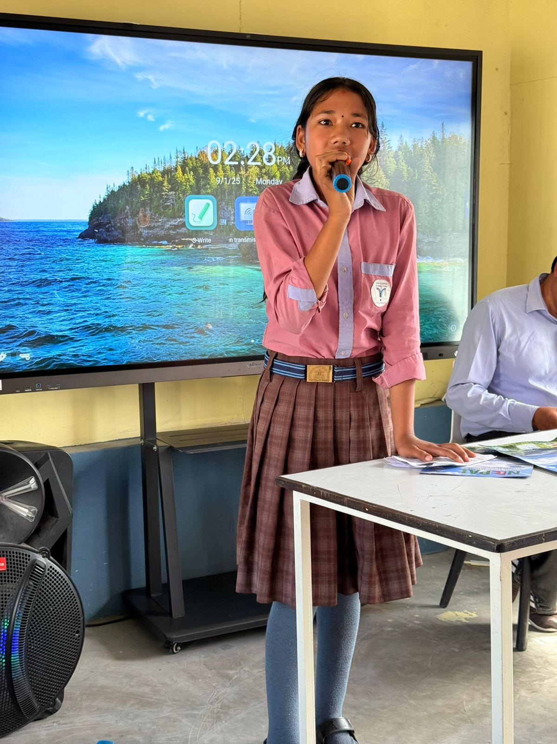

A student of the ecosystem club conducting a knowledge-sharing session on rainwater harvesting and groundwater recharge.

Reviewed By: Approved By:

SIGNATURE _________________ SIGNATURE _________________
Name: Mr. Durga Prasad Upadhyay Name: Mr. Prakrina Tuladhar
National Project Manager National Project Director
Urban EbA Urban EbA

